Lecture 3
The Socket API Continued
Remote Method Invocation
For Chapters 5 - 8 of Distributed Computing: Principles and Applications

For Chapter 5
The Client Server Paradigm

You need to read your book and practice the exercises. This is just an extra note for the chapter.
Read this lecture after you have read chapters 5 to 8 of your second textbook.

Introduction

From these first two chapters I clarify the concepts that are not explained in chapter 4. The client-server programs that I explained in this lecture in detail is about a concurrent server (section 5.5). This server services several clients.
Most of the programs are straightforward. However, there are programs that require you enter data in a command-line for the parameters of the method: main. To add data values for the parameter of this method follow the steps below:

1. From the menu bar click on Run → Run Configuration and click on the tab: Arguments to see:

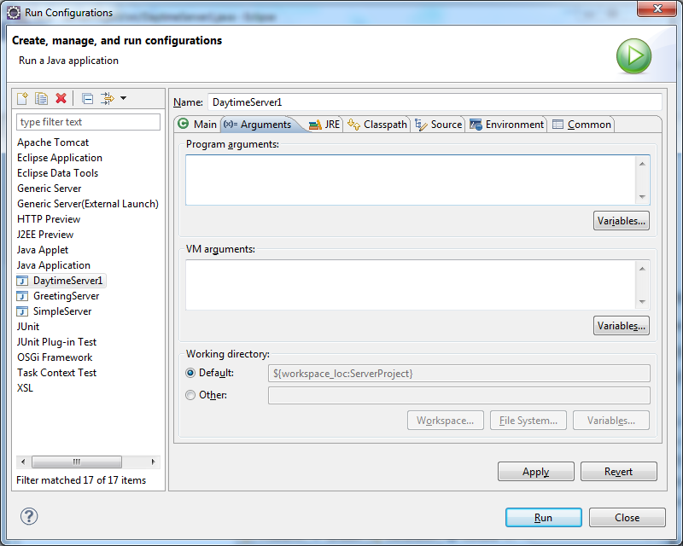

2. Enter your data values in the window labeled: Program arguments. If you have more than one data value separate them by a space.

5.1, 5.2, 5.3

The client server programs in these sections are similar to the ones in chapter 4.

Daytime Client-Server Using Stream-Mode Sockets:

The program in the book is rather sizeable. I rewrote this program in smaller and more understandable fashion.

Example 1: In the following program, the server sends the time of the day to the client using connection oriented stream:

The server:

import java.io.*;
import java.net.*;
import java.util.*;
public class MyServer {
public static void main(String[] args) throws IOException {
Socket clientSocket = null;
System.out.println("Daytime server ready.");
ServerSocket serverSocket = new ServerSocket(4321);
while(true){
//Wait on this line until the client gets connected.
clientSocket = serverSocket.accept();
System.out.println("Request received.");
//The value true, makes the println to flush the output buffer
PrintWriter out = new PrintWriter(clientSocket.getOutputStream(), true);
//Create a date object
Date timestamp = new Date ();
System.out.println("timestamp sent: "+timestamp);
//Send the date to the client
out.println(timestamp);
}
}
}

The client:

import java.io.*;
import java.net.*;//UnknownHostException;

public class MyClient {
public static void main(String[] args) throws UnknownHostException, IOException {
System.out.println("Welcome to the Daytime client.");
Socket clientSocket = new Socket("localhost", 4321);
BufferedReader in = new BufferedReader(new InputStreamReader(clientSocket.getInputStream()));
//Read (receive) the time stamp from the server.
String s = in.readLine();
System.out.println("Here is the timestamp received from the server: "+s);
in.close();
clientSocket.close();
clientSocket.close();
}
}

Description:

In this program the client gets the time stamp from the server, displays it and terminates.

The server:
- clientSocket = serverSocket.accept(): The server has to wait on this line until the client gets connected.
- Date timestamp = new Date (): Creates a date object.
- out.println(timestamp.toString()): Sends the date to the client.

The client:
- String s = in.readLine(): Reads (receives) the timestamp from the server.
- System.out.println("Here is the timestamp received from the server: "+s): The client prints the timestamp.

With using java classes PrintWriter and BufferReader for I/O we only can send and receive strings. In a program that deals with integers and decimal numbers, we need to convert the string with java classes Integer, Float, and Double.
With the Java classes: DataInputStream and DataOutputStream for I/O we do not need these extra classes.
Example 2: The following program is doing the same as the above one.
import java.net.*;
import java.io.*;
public class MyClient {
public static void main(String args[]) throws IOException {
Socket clientSocket = new Socket("localhost",1234);
DataInputStream in = new DataInputStream(clientSocket.getInputStream());
String s = new String (in.readUTF());
System.out.println(s);
clientSocket.close();
in.close();
}
}
import java.net.*;
import java.util.Date;
import java.io.*;
public class MyServer {
public static void main(String args[]) throws IOException {
Socket clientSocket = null;
DataOutputStream out = null;
ServerSocket serverSocket = new ServerSocket(1234);
while(true){
clientSocket = serverSocket.accept();
out = new DataOutputStream (clientSocket.getOutputStream());
Date timestamp = new Date ();
out.writeUTF("timestamp sent: "+timestamp);
}
}
}

Exercise 1: Using the approach in the above example write a client/server program such that the server sends two integers. The client receives these numbers and displays the sum of them on the console.

Daytime Client-Server Using Connectionless Datagram Sockets:

I do not explain this program. It is similar to the one in example 1. Example 3 in the previous lecture and the following example are of this kind.

Exercise 2: Convert the program in example 1 to a program using connectionless datagram socket.

5.4 Connection-Oriented and Connectionless Servers

When datagram is used in client-server programs the system needs to be sure a message (a packet) sent by a client has been received by a server. In this case the server should echo the message back to the client.

Note: The maximum size of a packet is: 65,535 bytes. 8 bytes are reserved for the software and the maximum size of a message is 65,527 bytes, If the sender sends a bigger size the JVM throws the following exception:

java.net.SocketException: The message is larger than the maximum supported by the underlying transport: Datagram send failed

Since in this approach a packet may not be received by the receiver it is the responsibility of the program to check. In the following program deals with this problem.

Example 3: In the following client-server program when the server receives a message from a client it echoes back the message to the client. In this example, we use datagram packet and socket. They are used in connectionless orientation. Each packet is sent based on the information within the packet. We can send packets to different computers. The delivery order is not guaranteed and also a packet may not reach to its destination.

The server:

import java.io.*;
import java.net.*;

public class MyServer {
public static void main(String[] args) throws IOException {

byte[] buffer = new byte[100];
//An empty buffer is constructed to be filled up
DatagramPacket datagram = new DatagramPacket(buffer, buffer.length);
//A socket for sending and receiving packets.
DatagramSocket clientSocket = new DatagramSocket(1234);
System.out.println("Echo server ready.");
while(true){
//Receive a datagram packet from this socket.
clientSocket.receive(datagram);
String message = new String(buffer);
System.out.println("From client: " + message);
//Send the same packet back.
clientSocket.send(datagram);
}
}
}

The client:

import java.io.*;
import java.net.*;
import java.util.*;

public class MyClient {
public static void main(String[] args) throws IOException {
System.out.println("Welcome to the Echo client.");
Scanner keyboard = new Scanner(System.in);
System.out.print("Enter a message to send or a period to quite: ");
String message = keyboard.nextLine();

while(! message.equals(".")) {
byte[] buffer = message.getBytes();
InetAddress host = InetAddress.getByName("localhost");
//A socket for sending and receiving packets.
DatagramSocket serverSocket = new DatagramSocket();
//Form a packet. The packet includes the host address and its port.
DatagramPacket datagram=new DatagramPacket(buffer,buffer.length,host, 1234);
//Send the packet.
serverSocket.send(datagram);
message = new String(buffer);
//Receive the same packet (hopefully !)
serverSocket.receive(datagram);
System.out.println("From server: "+ message);
System.out.print("Enter a message to send: ");
message = keyboard.nextLine();
serverSocket.close();
}
}
}

Description:

The server:

The while-loop iterates forever.
clientSocket.receive(datagram): When the server starts it blocks on this instruction until the client sends a message. Once the client sends a message it is stored in the variable: datagram.
clientSocket.send(datagram): Sends the same message back to the client.

The client:

The client keeps sending messages to the server until the user enters a period.
serverSocket.send(datagram): Sends a message to the server. The control of execution then blocks on: serverSocket.receive(datagram)until the server echoes back the message. In this case this instruction receives it. The echoed message is stored in the variable: datagram. The next instruction displays the echoed message.
Note that with the datagram system if the sender runs before the receiver runs we do not get error message and the data do not get to the receiver.

5.5 Iterative Server and Concurrent Server

In general, a server does not just serves one client. Normally they serve many clients. This section explains such a server. What we need is let the server create a java thread on the request of each client and code the thread to do the task requested by the client. To refresh your memory I first present a simple example to show how to generate threads in java. In this example, I am using the Java interface Runnable rather than the Java abstract class: Thread.

Before moving to a client-server program that is using threads to refresh your memory. Let us look at a simple program using threads.

Example 4: The following program creates two threads. Each of them adds two numbers. The method: main takes these two sums and multiply them:

public class Main {
public static void main(String[] args) throws InterruptedException {
MyThread m1 = new MyThread(2, 3);
MyThread m2 = new MyThread(4, 5);
Thread t1 = new Thread(m1);
Thread t2 = new Thread(m2);
t1.start();
t2.start();
t1.join();
t2.join();
System.out.println((m1.result*m2.result));
}
}

public class MyThread implements Runnable{
private int a, b;
public int result;

public MyThread(int a, int b){
this.a = a;
this.b = b;
}
public void run(){
result = a + b;
}
}

Output:

45

Description:

The class Main:

The Java Virtual Machine (JVM) always creates a thread to execute method: main. This is not a thread we create in our program. This thread has been there from the very first java program we have written. I call this thread the: main thread.

MyThread m1 = new MyThread(2, 3) and MyThread m2 = new MyThread(4, 5): Creates two objects where m1 and m2 are referring to.

Thread t1 = new Thread(m1): Creates a thread for: t1 to execute the method: run that the object: m1 is referring to. Note that:
The control of execution does not start the execution of method: run until the control executes: t1.start().

Thread t2 = new Thread(m2): Creates a second thread to execute the method: run that the object: m2 is referring to.

t1.start(): The control of execution starts executing the thread: t1. The thread adds 2 and 3 and stores in the public variable: result in class: MyThread.

t2.start(): The control of execution starts executing the thread: t2. The thread adds 4 and 5 and stores in the public variable: result in class: MyThread.

t1.join():The join method allows the main thread blocks on this instruction until the execution of the thread t1 is completed.

t2.join():The main thread blocks on this instruction until the execution of the thread t2 is completed.

System.out.println((m1.result*m2.result)): The main thread multiplies 5 and 9 and displays.

The class MyThread:

public class MyThread implements Runnable{: Runnable is a java interface. When a class (like: MyThread) implements a java interface (here Runnable) all the methods of the interface must be defined. In the interface: Runnable there is a method named: run whose signature is: public void run(). You must not change this signature. It must not have any parameter and must be of type void. When the control in the main thread executes: t1.start() (or t2.start()) it executes the method: run. In your program you must not call method: run.

Note: In class: MyThread in the instruction: this.a = a the left side refers to the instance variable: a but the right side refers to parameter: a.

We now are in a position to write a client-server program that the server can handle several clients.

Example 5: The server in following program creates a thread for any client. The server echoes back a message sent by a client. The client sends a message and the server displays it.

import java.io.*;
import java.net.*;

public class MyServer {
public static void main(String[] args)throws IOException, InterruptedException {
ServerSocket serverSocket = null;
serverSocket = new ServerSocket(4321);
while(true){
MyThread a = new MyThread(serverSocket.accept());
Thread t = new Thread(a);
System.out.println(t.getId());
t.start();
}
}
}

import java.io.*;
import java.net.*;

public class MyThread implements Runnable{
Socket clientSocket;

public MyThread(Socket clientSocket){
this.clientSocket = clientSocket;
}

public void run(){
try{
PrintWriter out = new PrintWriter(clientSocket.getOutputStream(), true);
BufferedReader in = new BufferedReader(new InputStreamReader(clientSocket.getInputStream()));
String s = in.readLine();
System.out.println("From the client: " + s);
out.println(s);
out.close();
in.close();
clientSocket.close();
} catch (IOException e){
System.out.println("Error from the thread: " + e);
}
}
}

import java.io.*;
import java.net.Socket;
import java.util.Scanner;

public class MyClient {
public static void main(String[] args) throws IOException {
Scanner keyboard = new Scanner(System.in);
try {
Socket clientSocket = new Socket("localhost", 4321);
PrintWriter out = new PrintWriter(clientSocket.getOutputStream(), true);
BufferedReader in = new BufferedReader(new InputStreamReader(clientSocket.getInputStream()));
System.out.print("Enter a message to send or a period to quite: ");
String s = keyboard.nextLine();
while(!s.equals(".")){
out.println(s);
s = in.readLine();
System.out.println("From server: "+ s);
System.out.print("Enter a line or a period to quit: ");
s = keyboard.nextLine();
}
clientSocket.close();
out.close();
in.close();
}catch (IOException e) {
System.out.println("Error: " + e);
System.exit(0);
}
}
}

Description:

The server:

The server iterates forever. For any new client the while-loop iterates once.
- The class MyServer:
ServerSocket serverSocket = new ServerSocket(4321): Open one port. Every client communicates with the server through this port.

In the while-loop we have:
MyThread a = new MyThread(serverSocket.accept()): Creates an object of the class: MyThread. The argument: serverSocket.accept() makes the thread to wait until a client connects to this server. The call to method: serverSocket.accept() returns a socket. We are passing this socket to the constructor of the class MyThread.

Thread t = new Thread(a): Argument: a refers to the object made in the previous instruction. We make this object to be a new thread.

Finally we start the execution of the thread.

- The class MyThread:
The code that we used to write in the method: main of a server we have in method: run.

The client:
The client has one class:
- The class MyClient:
This is similar to the client you wrote in project 1. It also is a version of the echo server in example 2 but it is a connection-Oriented server (see also pages: 160-165). The client repeatedly sends a message to the server and the server sends it back.

How to run these programs:
Make a work station for the server that has two classes: MyServer and MyThread.
Make several work stations with the client class: MyClient.
Run the server.
Run all of the clients.

5.6 Stateful Servers
Read this section.

5.7 Global State Information

This type of information in a server is accessible by all the clients. The server in page 170 has a static variable named: counter. Each client increments: counter. Since this variable is static we need to be sure no two or more clients access this variable at the same time. That is why the following method is defined as a synchronized method. Only one thread at a time can enter to a synchronized method in Java.

static private synchronized void increment( ){
counter++;
}

For Chapter 6
Group Communication

So far we had one server program and one client program that communicates with each other. In this chapter, we like to design client-server program such that a group of server/client programs communicate.

6.1 Unicast versus Multicast

A one-to-one (point-to-point) communication like in the previous sections and chapters is called Unicast. When a group of threads communicate is called Multicast (point-to-multipoints). See Figure 6.1, page 183.

6.2 An Archetypal Multicast API

The multicasting programs should have the following capability:
- Join Group: To include a new member.
- Leave: To remove a member desire to leave.
- Send: To send a message from one member to others.
- Receive: To receive messages from the members of the group.

6.3 Connectionless versus Connection-Oriented Multicast

In this system connectionless IPC is more efficient than connection-oriented. Suppose with the connection-oriented we have n processes (programs) to communicate. Suppose there are n processes that each of them sends and receives (like chat) messages. A process needs to send messages to the other n-1 processes. Since each process is a sender and receiver in a connection-oriented protocol we need to have (n -1)+(n-2)+...+2+1 connections. When n is large like 100 we need 4950 connections.

6.4 Reliable Multicasting versus Unreliable Multicasting

This is a very brief explanation of the section. For more detail read pages 185-188.

Communication between processes (programs) on a number of computers sitting on the internet should be carefully designed. Computers may have different operating systems, hardware and the programs may be written in different programming languages.

Unreliable Multicasting

If multicast software fails to transfer a message, part of the message, the receiver gets a corrupted message, or the receiver gets the same message more than once it is not reliable.

Reliable Multicasting

If multicast does not have the problems explained in the above paragraph, it is reliable. However in a reliable multicast system the messages may not been received in the same order. A process sends messages m₁ and m₂ in the order m₁, m₂ but the receiver may get them in m₂, m₁. Obviously, a reliable system on the other end will put the messages in the right order. The order of the messages from the sender to the receiver could be in FIFO (First in, First Out), an unorganized (Casual order) or automatic. In the automatic order, the order of messages sent by the sender won’t change.

6.5 The Java Basic Multicast API

As always let me explain the classes and methods that are needed for writing a multicast system through programs. But before explaining the following example I need to let you know:
We cannot use "localhost” or "vulcan.seidenberg.pace.edu". We need to barrow a multicast address. We need to pick up an address in the range: 224.0.0.2 to 239.255.255.255. In this range we have 2²⁸ which is 268,435,456 addresses. Pages 189-190.

Note: If you pick an address and you get an error message saying something like “The address is in use” pick a different address because somebody is using this address.

Example 6: In the following programs the sender sends the message: Hello All to all the receivers.
How to run the following programs:
1. Make a folder (I named it: Sender) for the sender class as an eclipse workstation.
2. Make a folder (I named it: Reciver1) for the receiver class as an eclipse workstation.
3. Copy the folder: Reciever1 several times and rename them Reciever2, Reciever2,
4. Put all of them on the screen narrow the eclipse editors such that all of them visible.
5. Run all the receivers first.
6. Run the sender.
You must see the message: Hello All in all the receivers’ consoles.

import java.io.IOException;
import java.net.*;
public class MyClient{
public static void main(String[] args) throws IOException{
InetAddress group = InetAddress.getByName("239.1.2.3");
MulticastSocket s = new MulticastSocket(3456);
s.setTimeToLive(32);
String msg = "Hello All.";
DatagramPacket packet = new DatagramPacket(msg.getBytes(), msg.length(), group, 3456);
s.send(packet);
s.close();
}
}

import java.io.IOException;
import java.net.*;

public class MyServer{
public static void main(String[] args) throws IOException{
InetAddress group = InetAddress.getByName("239.1.2.3");
MulticastSocket s = new MulticastSocket(3456);
System.out.println("Joined group at 239.1.2.3 port 3456");
s.joinGroup(group);
byte[] buf = new byte[100];
DatagramPacket recv = new DatagramPacket(buf, buf.length);
s.receive(recv);
System.out.println(new String(buf));
s.close();
}
}

Output:

Hello All

Description:

MyClient:
- InetAddress group = InetAddress.getByName("239.1.2.3"): We had this class in the previous chapters. The IP address must be in the range: 224.0.0.2 to 239.255.255.255.

- MulticastSocket s = new MulticastSocket(3456): This is used to send and receive packets. It is a UDP DataGramSocket with the ability for joining a member of a group by calling the method joinGroup.

- s.setTimeToLive(32): Sets the default time-to-live for multicast packets sent out on this MulticastSocket in order to control the scope of the multicasts. The scope of the multicast is shown on page 193. The default value is zero. Multicast packets sent with a TTL of 0 are not transmitted on the network but may be delivered locally.

- DatagramPacket packet = new DatagramPacket(msg.getBytes(), msg.length(), group, 3456): Constructs a datagram packet object to send packets of specific length.

- s.send(packet): Sends a datagram packet from this socket.

MyServer:
- InetAddress group = InetAddress.getByName("239.1.2.3"): Is creating an address object. The host is: "239.1.2.3". The sender and all the receivers must have the same host. In this case all of them belong to the same group.
- MulticastSocket s = new MulticastSocket(3456): A multicast socket object with the same host as the sender’s port. The variable: s refers to this socket.
- s.joinGroup(group): It is this instruction that makes the socket to be a member of the same group (same host).

Note: If in a program we need to remove a member we call the method: s.leaveGroup(group).

Read example 2 in pages 195-197 and write classes for the following exercise:

Exercise 4: Write three sender/receiver programs such that the first one sends a message to the second one. The second one adds a phrase to the message and sends it to the third one.

6.6 Reliable Multicast API

The API that with them we wrote the program in the above example provides unreliable multicasting. Some of the message sent by senders may not reach to a desired receiver, However there are reliable multicast API like JRM and Tom in the market (read page 197, section 6.6).

For Chapter 7
Distributed Objects

Introduction

So far we learned how to send and receive messages in a unicast and multicast systems. We now go over sending and receiving from objects.
Note: Since we are dealing with threads in java I name a process: a program.

7.1 Message Passing versus Distributed Objects

The message passing systems may not be appropriate for complex applications because:
- Processes (programs) in the message passing paradigm are tightly coupled. If the communication between client/server disrupted then the session cannot continue.
- The message passing paradigm is data-oriented. The processes transfer data to each other.

In the distributed object paradigm it is the objects that communicate with each other. Since an object contains data values in the instance variables and methods not only a process (program) sends and receives data values a process (program) can also call a method of an object which resides in a program of another website on the internet (figure 7.1).

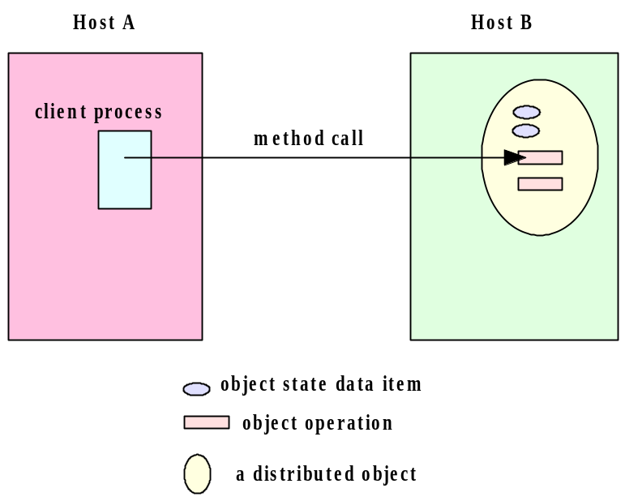
7.2 An Archetypal Distributed Object Architecture

Figure 7.2 in page 206 shows an archetypal distributed object. On the server side the server program creates an object which is called: object server. The object is registered by the (object) registry (A registry is an object on the server side). On the client side the client program creates an client object. The client program then looks at the (object) registry to make sure the object can be referenced. The client object uses this reference to call the methods of the object server. These methods are called remote methods. A call to a remote method is processed by a client proxy which is a software that knows how to communicate with the server proxy. The sever proxy refers to the object server to invoke the method and send the result back to the client proxy. The client proxy in turn gives the result to the object client.

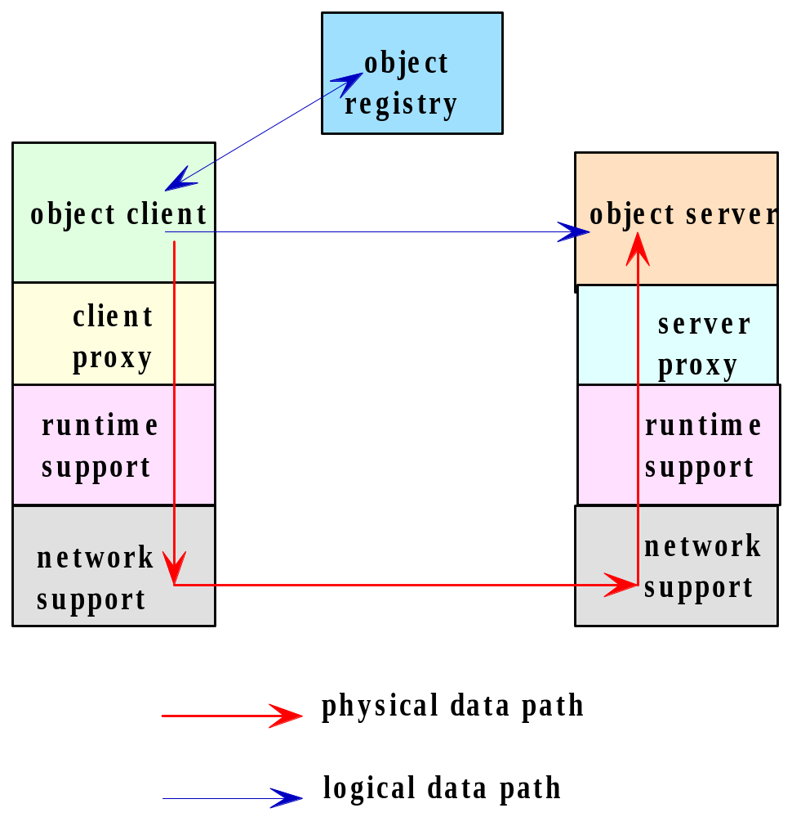

7.3 Distributed Object System

The java programmer use Java Remote Method Invocation (RMI), Common Object Request Broker Architecture (CORBA) and/or the Distributed Component Object Model (DCOM) software for distributed programming. In this and the next chapters we learn how to use Java RMI and its communication mechanism.

7.4 Remote Procedure Calls

The base of RMI is the Remote Procedure Call (RPC). RPC is used in the procedural programming language like C. Figure 7.3 shows how processes over the network call a procedure (function). Process A calls a procedure proc1 that is resided in process B. Process B executes the procedure and sends the return value (if any) to process A. Figure 7.4 is more clear and precise. In this figure (see the book) a process in our computer calls procedure: proc1. This procedure calls procedure: proc2 which is defined on a remote computer. The system executes: proc2 and returns the result to the caller (proc1).

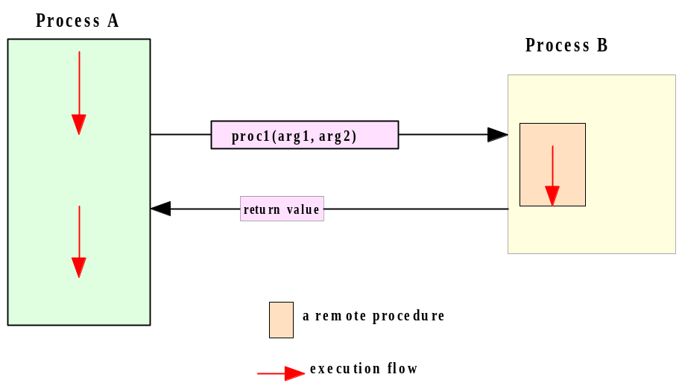

7.5 Remote Method Invocation

RMI is an extension of RPC. In RPC we are dealing with procedures. In RMI we deal with objects. We define a class on the client side to create a client object and a class on the server side to create a server object. We also define an interface and server class implement the interface. The interface that we define inherits the java interface: Remote. The interface that we define has the signature of some methods that the client can call. The server side implements this interface to define the methods of the interface. The client side does not implement this interface but the interface is available to be used.

7.6 The Java RMI Architecture

Figure 7.5 shows the mechanism of a remote call. The client side is on the left and the server side is on the right.
The object client sends a remote method call to its stub (i.e. proxy). The client remote reference layer sends the call to the client transport layer. The transport layer sends the call to the transport layer of the server. This layer sends the call to the server reference layer to interpret for the object server. The server executes the call and sends the result back to the object client.

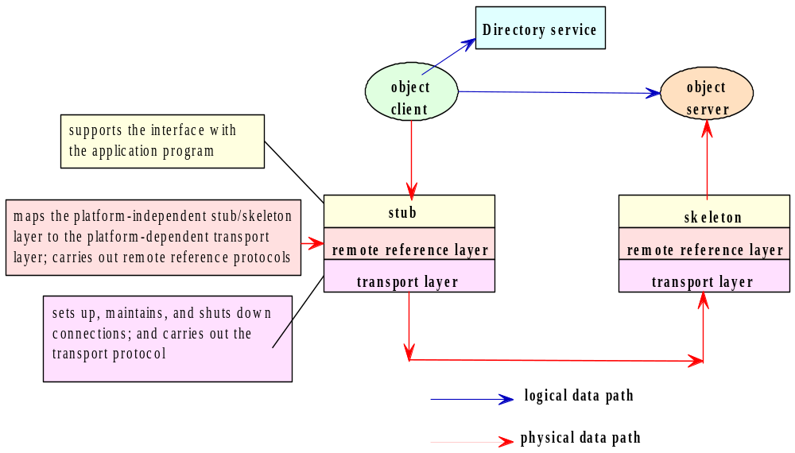

The stub is an object, as a gateway for the client program. When the client program calls a method that is implemented on the server program the stub does the following:

1. Connects to the remote Virtual Machine (JVM),
2. It sends (marshals) the arguments of the method to the remote Virtual Machine (JVM),
3. Waits for the result
4. Reads (un-marshals) the return value
5. Returns the value to the caller.

The skeleton is an object, as a gateway for the server side object. All the incoming requests are routed through it. When the skeleton receives the incoming request, it does the following tasks:

1. Reads the parameter for the remote method
2. Calls the method on the actual remote object
3. Sends (marshals) the result to the caller.

7.7 & 7.8 the API for Java RMI

I explain the API through a simplified version of the client server programs from pages 220-224. We need java interface and classes to:

1. Create the remote interface.
2. Use (but not implement) the interface on the client side.
3. Implement the remote interface by a class on the server side.
4. Start the registry service by rmiregistry tool

Note: On the client side we need to define at least one class. On the server side we need to define at least two classes.

Example 7: In the following client-server programs the client calls a method of the server.

The client side class and interface:

import java.rmi.*;
public interface HelloInterface extends Remote {
public String sayHello(String name) throws RemoteException;
}

import java.net.MalformedURLException;
import java.rmi.*;

public class HelloClient{
public static void main(String args[]) throws MalformedURLException, RemoteException, NotBoundException{
int port = 16790;
String host = "localhost";
String registryURL = "rmi://" + host + ":" + port + "/hello";
HelloInterface h = (HelloInterface)Naming.lookup(registryURL);
System.out.println("Lookup completed " );
String message = h.sayHello("Donald Duck");
System.out.println("HelloClient: " + message);
}
}

The server side classes and interface:

import java.rmi.*;
import java.rmi.registry.LocateRegistry;
import java.net.*;

public class HelloServer{
public static void main(String args[]) throws RemoteException, MalformedURLException{
int port = 16790;
String host = "localhost";
HelloImpl exportedObj = new HelloImpl();
LocateRegistry.createRegistry(port);
String registryURL = "rmi://" + host + ":" + port + "/hello";
Naming.rebind(registryURL, exportedObj);
System.out.println("Hello Server ready.");
}
}

import java.rmi.*;
import java.rmi.server.*;

public class HelloImpl extends UnicastRemoteObject implements HelloInterface {
public HelloImpl() throws RemoteException {
super( );
}

public String sayHello(String name) throws RemoteException {
return "Hello, World!" + name;
}
}

Description:

The interface:

public interface HelloInterface extends Remote{
public String sayHello(String name) throws RemoteException;
}

This is a java interface. The java class: Remote informs the client that the method: sayHello is implemented remotely (on the server side). This interface is not implemented on the client side.

Note: Since we write all the programs with eclipse you do not have to memorize which exception class should be used here and there. The eclipse tells you which exceptions you need.

Note that this interface is in both the client and server sides. This interface is implemented by the class: HelloImpl in the server program and is not implemented in the client program.

The RMI system has a registry objects. Every remote object must have a name registered in the registry.

The server side:

The class HelloImpl:
- The server creates an object of this class. This object is going to be the remote object. The method: sayHello of this remote object can be called by the client program.

The class HelloServer:
- Method: main:
  - String registryURL = "rmi://" + host + ":" + port + "/hello": This make the string: "rmi://localhost:16790/hello". This string is going to be registered in the registry as the name of the remote object that the variable: exportedObj refers to.
Note: The word: hello is optional. You can change it on both sides to any name.
  - LocateRegistry.createRegistry(port): Creates and exports a registry object on the specified port.
  - Naming.rebind(registryURL, exportedObj): Naming is a class in the package rmi. The method: rebind associates (binds) the above string (blue underlined) with the remote object: exportedObj.

The client side:

The class HelloClient:
- String registryURL = "rmi://" + host + ":" + port + "/hello": This make the string: "rmi://localhost:16790/hello". This string must be in the rmi registry as the name of a remote object. The variable: host is the host where the registry is located. The variable: port is the port number on which the registry on the server side accepts calls. Both host and port are optional. If host is omitted, the host defaults to the local host. If port is omitted, then the port defaults to 1099, the "well-known" port that rmi registry uses.
- HelloInterface h = (HelloInterface)Naming.lookup(registryURL): The method: looks up for the argument (the blue underlined). This name refers to a remote object. Therefore the variable: h refers to the remote object. Now h can access to any public method and variable of this remote object which is of type class: HelloImpl.
- h.sayHello("Donald Duck"): passes the argument: to the following method. The method returns the string: "Hello, World!Donald Duck".
public String sayHello(String name) throws RemoteException{
return "Hello, World!" + name;
}

Exercise 5: Write a client server program using RMI. The client sends two integers. The server subtract these numbers and sends the result back to the client.

Exercise 6: Write a client server program using RMI for a bank account. The client sends two integers. The server subtract these numbers and sends the result back to the client.
import java.rmi.Remote;
import java.rmi.RemoteException;

public interface AccountInterface extends Remote {
public void setName(String name) throws RemoteException;
public void setBalance(float amt) throws RemoteException;
public String getName() throws RemoteException;
public float getBalance() throws RemoteException;
public void withdraw(float amt) throws RemoteException;
public void deposit(float amt, String name) throws RemoteException;
public void transfer(float amt, Account src) throws RemoteException;
}

For Chapter 8
Advanced RMI
In this chapter more application of the API of rmi is presented. The chapter explains how to use the java security manager. We go over two rmi programs: A more sophisticated program and a program that deals with the security manager.

8.1 Client Callback

A client program in real time does not know when the remote object is available. For example it takes some time to obtain the result (like sorting millions of names) that should be sent back to the client. In this case the client program has to poll (check) for the availability of the result repeatedly until it is available. This idea can be coded as follows:

CallbackServerInterface h = (CallbackServerInterface)Naming.lookup(registryURL);
while(!(h.hasBiddingStarted())
;

Where the method: hasBiddingStarted() is a remote method that returns true when the remote object obtains the result to be sent to the client. As long as this remote method returns false the above while-loop cycles around. Obviously this is not an efficient solution. The thread that is responsible for the execution of the client program is wasting CPU time by sitting on this loop. A more efficient solution is the callback technique. In this technique we code the client to go to sleep for a period of time. In this case CPU leaves the thread that is executing the client program to do (execute) some useful work for other programs in the system. Let us clarify this technique through an example.

Example 8: The following client-server program implements the callback technique.

Interfaces: Both sides have the same interfaces:

import java.rmi.*;

public interface CallbackClientInterface extends Remote{
public String notifyMe(String message) throws RemoteException;
}

import java.rmi.*;

public interface CallbackServerInterface extends Remote {
public String sayHello( ) throws RemoteException;

public void registerForCallback(CallbackClientInterface callbackClientObject)
throws RemoteException;

public void unregisterForCallback(CallbackClientInterface callbackClientObject)
throws RemoteException;
}

The server side:
import java.rmi.*;
import java.rmi.server.*;
import java.util.Vector;

public class CallbackServerImpl extends UnicastRemoteObject implements
CallbackServerInterface{

private Vector clientList;

public CallbackServerImpl() throws RemoteException{
super( );
clientList = new Vector();
}

public String sayHello( )throws RemoteException{
return("hello");
}

public synchronized void registerForCallback(CallbackClientInterface
callbackClientObject)throws RemoteException{
if (!(clientList.contains(callbackClientObject))){
clientList.addElement(callbackClientObject);
System.out.println("Registered new client ");
doCallbacks();
}
}

public synchronized void unregisterForCallback(
CallbackClientInterface callbackClientObject) throws RemoteException{

if (clientList.removeElement(callbackClientObject)){
System.out.println("Unregistered client ");
}else{
System.out.println("unregister: clientwasn't registered.");
}
}

private synchronized void doCallbacks( ) throws RemoteException{
System.out.println("**************************************\n Callbacks initiated ---");
for (int i = 0; i < clientList.size(); i++){
System.out.println("doing "+ i +"-th callback\n");
CallbackClientInterface nextClient =
(CallbackClientInterface)clientList.elementAt(i);
nextClient.notifyMe("Number of registered clients=" + clientList.size());
}
System.out.println("********************************\n Server completed callbacks ---");
}
}

import java.rmi.*;
import java.rmi.registry.LocateRegistry;
import java.net.*;

public class CallbackServer{
public static void main(String args[]) throws RemoteException, MalformedURLException{
int port = 1234;
String host = "localhost";
LocateRegistry.createRegistry (port);
CallbackServerImpl exportedObj = new CallbackServerImpl();
String registryURL = "rmi://" + host + ":" + port + "/callback";
Naming.rebind(registryURL, exportedObj);
System.out.println("Callback Server ready.");
}
}

The client side:
import java.rmi.*;
import java.rmi.server.*;

public class CallbackClientImpl extends UnicastRemoteObject
implements CallbackClientInterface {

public CallbackClientImpl() throws RemoteException {
super( );
}

public String notifyMe(String message){
String returnMessage = "Call back received: " + message;
System.out.println(returnMessage);
return returnMessage;
}
}

import java.util.Scanner;
import java.net.MalformedURLException;
import java.rmi.*;

public class CallbackClient {
public static void main(String args[]) throws MalformedURLException,
RemoteException, NotBoundException, InterruptedException{
Scanner keyboard = new Scanner(System.in);
int port = 1234;
String host = "localhost";
System.out.println("Enter how many seconds to stay registered:");
int time = keyboard.nextInt();
String registryURL = "rmi://" + host + ":" + port + "/callback";
CallbackServerInterface h = (CallbackServerInterface)Naming.lookup(registryURL);
System.out.println("Lookup completed " );
System.out.println("Server said " + h.sayHello());
CallbackClientInterface callbackObj = new CallbackClientImpl();
h.registerForCallback(callbackObj);
System.out.println("Registered for callback.");
Thread.sleep(time * 1000);
h.unregisterForCallback(callbackObj);
System.out.println("Unregistered for callback.");
}
}

We run the server side first and then the client side and enter data on the client console.

A sample dialog:
Client side console:
Enter how many seconds to stay registered:
10
Lookup completed
Server said hello
Call back received: Number of registered clients=1
Registered for callback.
Server side console:
Callback Server ready.
Registered new client
**************************************
Callbacks initiated ---
doing 0-th callback

********************************
Server completed callbacks ---
Unregistered client

Description

This is similar to your project 2. But in Project 2 both sides are sending and receiving strings. Here both sides need to call a remote method of the other side. Therefore both sides have remote objects. Obviously like the previous example the remote object on the server side has the method: sayHello and the client program calls this remote method.

The server program:
interface CallbackClientInterface: The method: notifyMe of this interface won’t be implemented by the server program. The server calls this remote method which is residing in a remote object on the client side.

interface CallbackServerInterface: The methods sayHello and registerForCallback are implemented on the server side and the client calls them remotely.
Therefore the roles of these two interfaces on the client side are switched.

The class CallbackServerImpl:
- Since many clients may call the remote object of this server program we need a java Vector: clientList to record them.
- The method sayHello: This method is called by the client side remotely to receive: "hello".
- The method registerForCallback: This is a method which is called by many clients remotely. Since every client is changing the vector: clientList by adding itself which is referred by the parameter: callbackClientObject. This method must be a synchronized method to prevent more than one client going inside its body. Therefore any local call like: doCallbacks in the body of this method must also be a synchronized method.
- The method doCallbacks: This method is called by the above method. The major instruction in the body of this method is the remote (on the client side) method call: notifyMe(...). The server side is asking the client to notify him that has received the word: "hello".
- The method unregisterForCallback: This remote call which is called by a client removes the client from the vector and this means this client is not registered anymore.

The class CallbackServer:
- The method main: This method is almost the same as the one in example 1 of chapter 7. It creates a remote object of the type of the class: CallbackServerImpl to be used by the clients remotely.

The client side program:
The interfaces are doing the opposite of the ones in the server side. Their roles are explained in the description of the server program.

The class CallbackClientImpl:
- The method notifyMe: This is a remote method which is called by the server. This method returns a message (Call back received...) to let the server which means this client is connected and registered.

The class CallbackClient:
- The method main:
  - CallbackServerInterface h = (CallbackServerInterface)Naming.lookup(registryURL): Finds the remote object created by the server and makes h refer to it. Now we can call any remote method on the server via: h.
  - h.sayHello(): Now the client via: h is calling the remote method: sayHello which is on the server side to get the word: hello.
  - new CallbackClientImpl(): The main method creates a remote object that the server can call methods.
  - h.registerForCallback(callbackObj): Calls this remote method to store itself (referred by the variable: callbackObj) in the vector which is on the server side.
  - Thread.sleep(time * 1000): Thread refers to a thread made by JVM to execute the method: main. The call to the method: sleep postponed the execution of the rest of the instructions in main for a few second. Therefore we are not using the polling technique explained at the beginning of this chapter to waste the time of this thread. This thread can now go and execute some of the programs of the system. After the sleeping time is over the CPU will come back to execute the rest of the instructions.
  - h.unregisterForCallback: Calls the remote method (defined on the server) to remove itself from the vector.

8.3 RMI Security Manager

As long as the clients and the servers are in your local machine we do not need to bother about the security problem. Once one of them is in a computer on the network we need to have java security features that both clients and servers must use. The server should know which clients are accessing to and the client should know to which server it can connect.

Note: Be very careful on using computers on the network. Normally we have router at home and even if we directly connect our computer to the modem the IP (In the DOS window enter: ipconfig) is not the external IP that is used by the internet company provider used on the network for our computers at home. The other problem is if your internet is slow or using a server far from your place you get a time exception error. Therefore I suggest you to not stay in this section struggling with your computer. Just have both the server on the client in your computer to learn this section.

When our server and client programs are in different computers and using RMI mostly we get exception errors because of security constraints. To handle security we need to use a class from rmi named: SecurityManager and to call a method named: setSecurityManager from the class: System. This is what we need:

System.setSecurityManager(new SecurityManager())

We also need to have a file where the class files are located with extension: policy. Normally we name this file: java.policy. In this file we write instructions to inform the system which clients are allowed to connect to the server (See page 252).

Example 9: The following client-server programs are the same as example 7 with additional code for the security manager:

The Server:
//java -Djava.security.policy=java.policy HelloServer
import java.rmi.*;
import java.rmi.registry.LocateRegistry;
import java.net.*;

public class HelloServer{
public static void main(String args[]) throws RemoteException, MalformedURLException{
System.setSecurityManager(new SecurityManager());
int port = 52365;
String host = "localhost";
HelloImpl exportedObj = new HelloImpl();
LocateRegistry.createRegistry(port);
String registryURL = "rmi://" + host + ":" + port + "/hello";
Naming.rebind(registryURL, exportedObj);
System.out.println("Hello Server ready.");
}
}

The client:
//java -Djava.security.policy=java.policy HelloClient
import java.net.MalformedURLException;
import java.rmi.*;

public class HelloClient{
public static void main(String args[]) throws MalformedURLException,
RemoteException, NotBoundException{
System.setSecurityManager(new SecurityManager());
int port = 52365;
String host = "localhost";
String registryURL = "rmi://" + host + ":" + port + "/hello";
HelloInterface h = (HelloInterface)Naming.lookup(registryURL);
System.out.println("Lookup completed " );
String message = h.sayHello("Donald Duck");
System.out.println("HelloClient: " + message);
}
}

The java policy: The name of the file is: java. Policy

grant{
// Allow RMI clients to make socket connections to the public ports on any host
// If you start the RMIregistry on a port in this range, you will not incur a resolve access violation.
permission java.net.SocketPermission "*:1024-65535", "connect, accept, resolve";
// Permits socket access to port 80, the default HTTP port needed by client to contact an HTTP server for stub downloading
permission java.net.SocketPermission "*:80", "connect";
};

To sever space I did not copy/paste some classes. Just get them from example 1, chapter 7.

How to run:

Like always make two folders, two versions of eclipse. Name the project file for the client: client-project and name the project file for the server: server-project. Copy the file java.policy in the folder: bin for both the server and the client.
The structure of the folder bin in both the client folder and the server folder are:

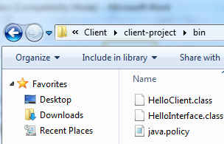 | 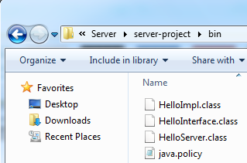

1. Open a DOS window for the server and a DOS window for the client.
2. Change the directory to the folder: bin in both DOS windows.
3. On the DOS prompt for the server enter:

java -Djava.security.policy=java.policy HelloServer

5. On the DOS prompt for the client enter:

java -Djava.security.policy=java.policy HelloClient

Outputs:
Output in the DOS window for the server:

RMI registry created at port 52365
Hello Server ready.

Output in the DOS window for the client:
Lookup completed
HelloClient: Hello, World!Donald Duck

Description:

The only instruction added with respect to the programs in example 1 of chapter 7 in both: HelloServer.java and HelloClient.java is:

System.setSecurityManager(new SecurityManager());

By adding this instruction when we run the java program the JVM is looking in folder: bin for a policy file. In this file we have one instruction (the rest are comments):

permission java.net.SocketPermission "*:1024-65535", "connect, accept, resolve";

This means the permission of any client that communicates with the server through a port number in the range: 1024-65535 is granted. The port number in both programs is: 16790.

